**Color blind accessibility android app**

1. Install Android Studio from [these instructions.](https://docs.google.com/document/d/10YFPoM6By201u5EgzJMfNjy7U11QNmVsFjB9XiOD5lY/edit?usp=sharing) (It will take a few minutes to install.)
2. Download the code from <http://bit.ly/2q3pxgt>.  
     
   You can also view the code on GitHub here: <https://github.com/milk-modules/Apps/tree/master/non-accessible/DemoApp02-BalloonSimple>
3. Extract the zip file into a directory on the C: drive.  
   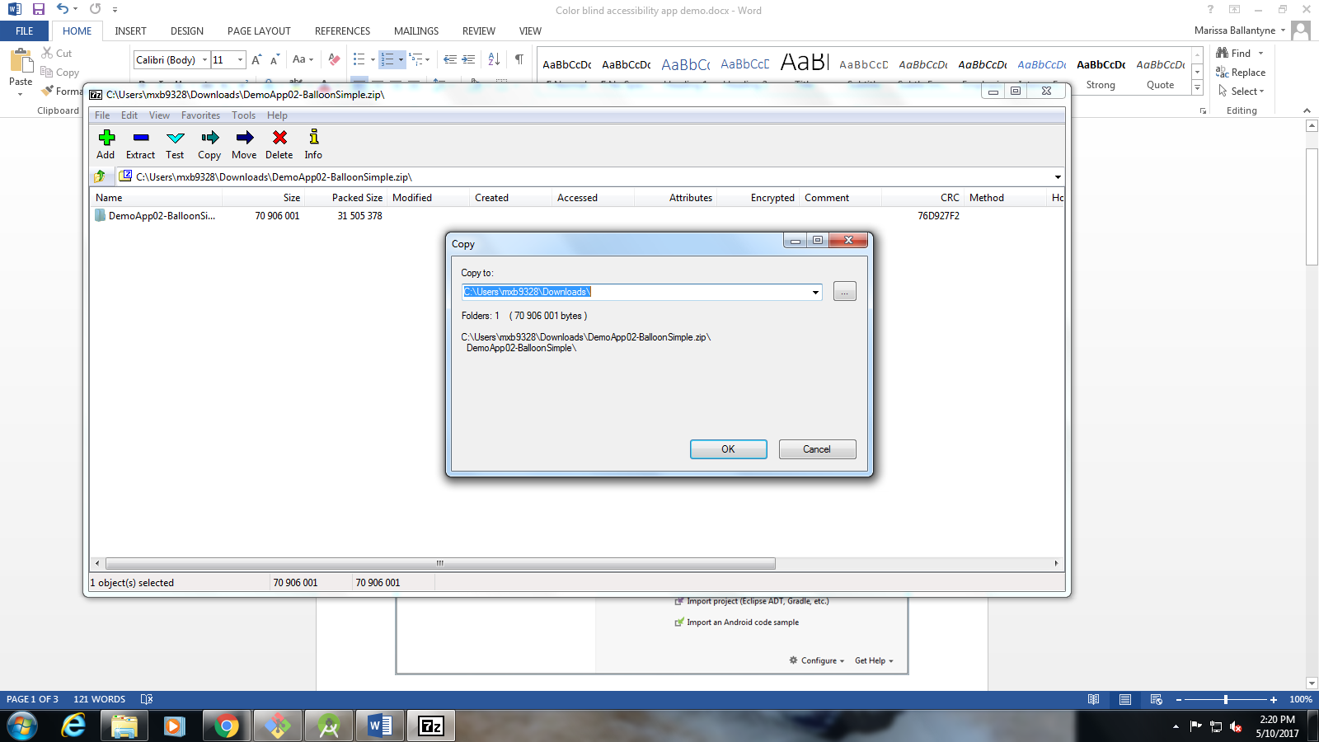
4. Import project in to Android studio
   1. Open Android studio.
   2. Import project in Android studio

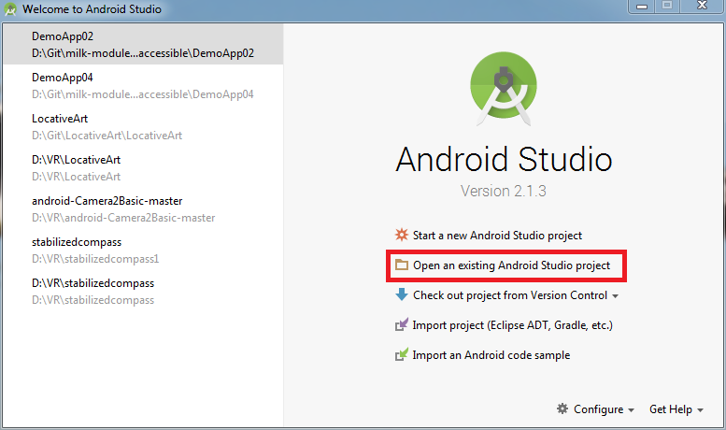

* 1. Open the directory you unzipped the activity into.

1. Run the project using the emulator.

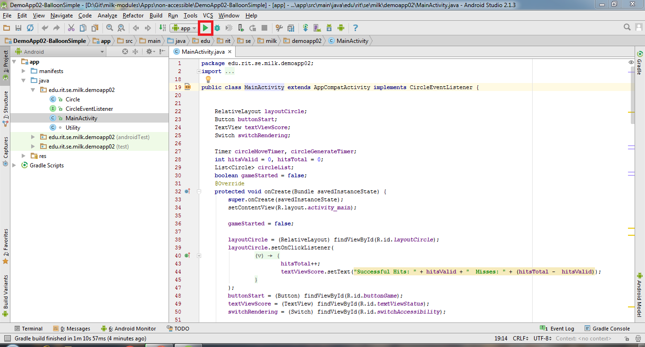

* 1. Once the emulator starts up, select the “balloon game” app on the Apps screen.

1. You will be able to see an app that is non-accessible to color-blind users.

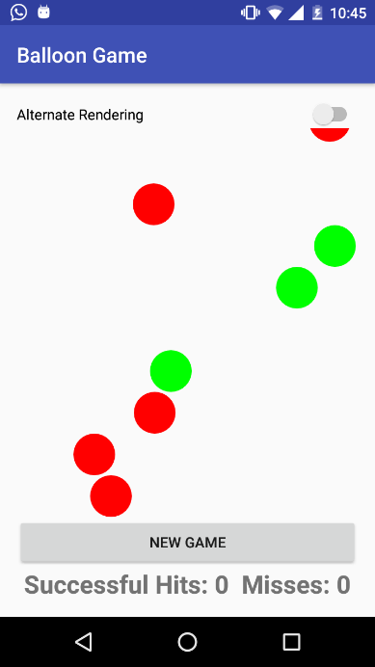 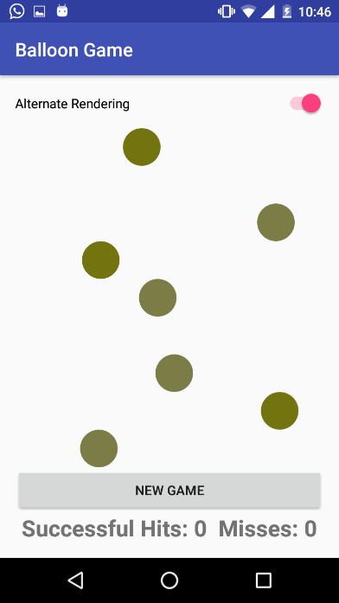

1. To fix this follow the following steps:
   1. Open Circle.java file
   2. On line 36, paste the following code

**if**(**isPoppable**) {  
 Paint paint = **new** Paint();  
 paint.setColor(**textColor**);  
 paint.setTextSize(64f);  
 paint.setAntiAlias(**true**);  
 paint.setTextAlign(Paint.Align.***CENTER***);  
  
 canvas.drawText(**"+"**, **x**, **y** + **circleRadius** / 2, paint);  
}

* 1. Run the project again and see the difference

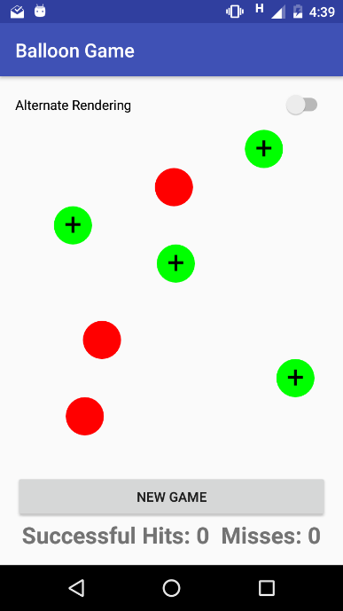 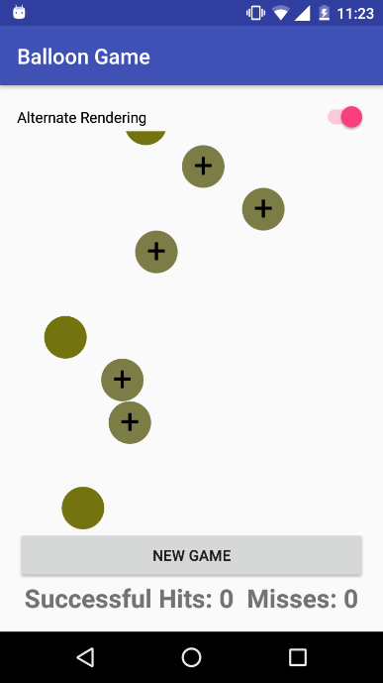

**Troubleshooting:**

When you first open the project, you may be unable to run it because of this error:

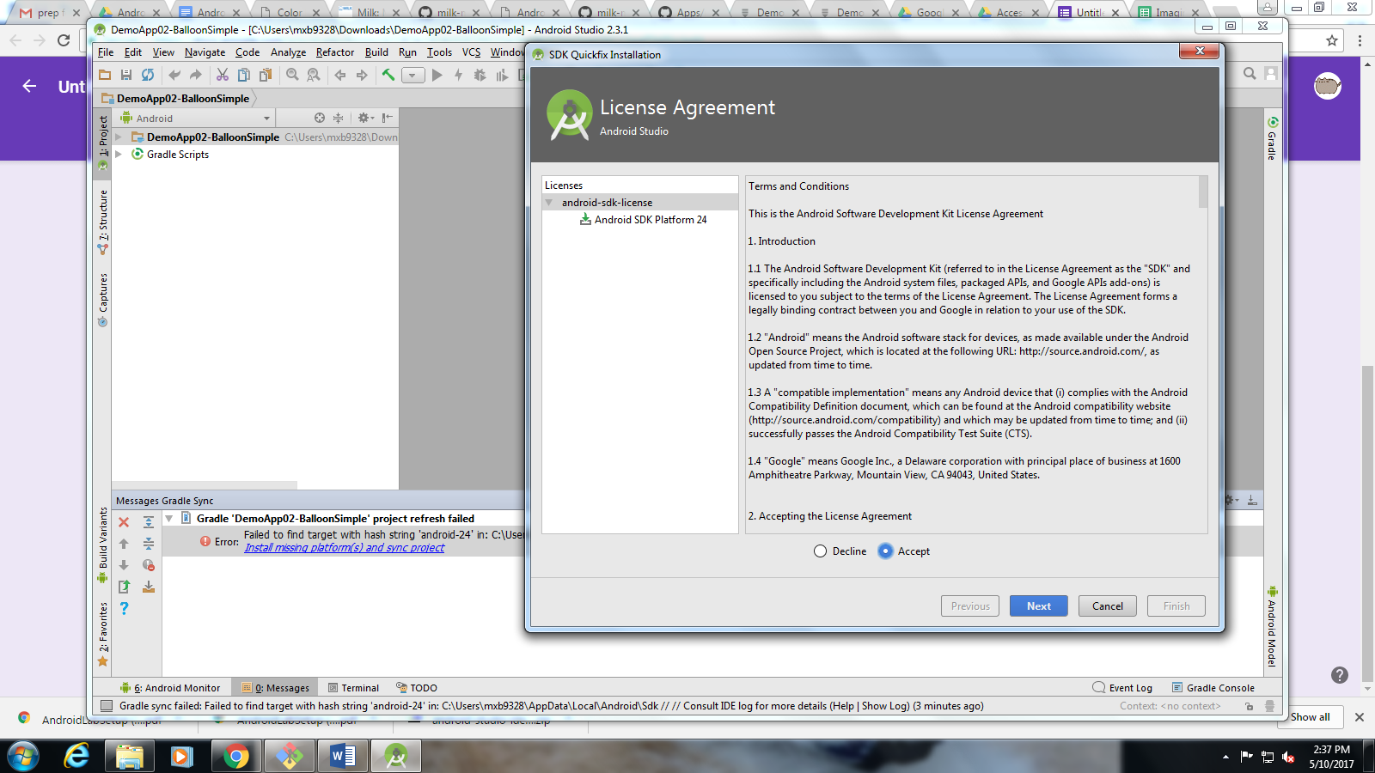

Click on the blue text and select “Accept” and then “Install” on the popup.